A000-Afr-Niger-Bura-Male Head with Mustache-3rd to 11th century CE

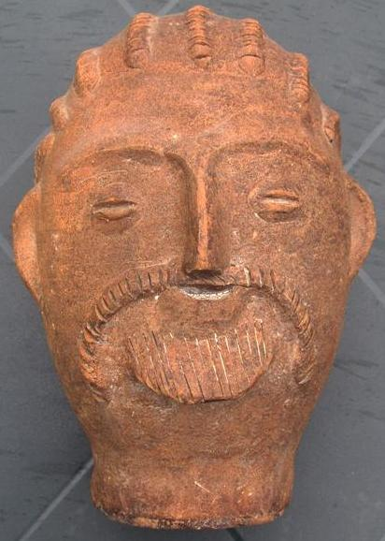

Fig. 1. Afr-Niger-Bura-Male Head with Mustache-3rd to 11th century CE

Case No.: 6

**Accession No.**

**Formal Label:** Afr-Niger-Bura-Male Head with Mustache-3rd to 11th century CE

**Display Description:**

Niger, Bura Iron Age culture (3rd to 11th century CE)-Terracotta head, , excellent condition showing fine detail of a closely cropped mustache and beard, a distinctive hair style in dreadlocks and Semitic facial features. This terracotta figure possibly of an ancestor. The facial features suggest that this but is of a trader who came to settle among the Bura people. It suggests that this is evidence of long-distance trade and exchange from Northeastern Africa to the Niger River valley.

Numerous clay objects have come to light from the great Inland Delta Cultures of the Niger River and Benue River confluence. The figure was fired at a relatively low temperature to give it the brownish-red color.

The Bura Iron Age culture (3rd to 11th century CE) is named for the Bura archaeological site first discovered in the [Tillabéry Region](http://en.wikipedia.org/wiki/Tillabéry_Region), [Tera Department](http://en.wikipedia.org/wiki/Tera_Department), SW [Niger](http://en.wikipedia.org/wiki/Niger), in 1975. Two other sites of especial note are Asinda and Sikka in Burkina Faso and Niger respectively. The Bura culture encompasses a set of [archeological](http://en.wikipedia.org/wiki/Archeological) sites in the lower [Niger River](http://en.wikipedia.org/wiki/Niger_River) valley bordering SW [Niger](http://en.wikipedia.org/wiki/Niger) and SE [Burkina Faso](http://en.wikipedia.org/wiki/Burkina_Faso). Excavated objects include terracotta heads, vessels and funerary urns, stone heads and iron arrow points. The terracottas have distinctive raised clay curvilinear motifs of unknown meaning.

The Bura culture belongs to a set of archaeological sites in the middle Niger valley in an area 250km long and about 150 km wide.   
The Bura site consists of many individual [necropoleis](http://en.wikipedia.org/wiki/Necropoleis) with coffins crested by unusually-distinctive [terracotta](http://en.wikipedia.org/wiki/Terra_cotta) [statuettes](http://en.wikipedia.org/wiki/Statuette). The main [necropolis](http://en.wikipedia.org/wiki/Necropolis) itself has a diameter of about one kilometer. Burial mounds, religious altars, and ancient dwellings occur here over a large area. In 1983 a site 25 meters by 20 meters was excavated.

Bura includes 3 types of sites that are not always easy to distinguish from each other:  
 1) Sites with necropolis proper characterized by a particular kind of coffin jars or anthropomorphic funerary urns made up of pottery surmounted by heads of statuettes, placed upside down on the ground and containing human skeletons in Asinda-sikka. These sites include 2 distinct archaeological levels. This is the type of site from which the present head has come.   
 2) Sites of religious altars and ritual ceremonies characterized by piles of large blocks of stone form a sort of flattened tumulus or esplanades such as Asinda-Sikka, Karey-Tondi, Jajé-Tondi or Mebera-Tondi There are fragments of feet of tripod vases and fragments of pottery in the form of small painted cylinders.  
 3) Housing sites difficult to identify. But the discovery of fragments of tripod vases and sometimes of small piles and alignments of large blocks of stone testify to a human presence. Also on the site are quarrying wastes of quartzites or flint representing the site of arched framework and thin ceramic of Kosendo-gorizo ​​located to the west of necropolis, behind a hill.  
  
 The general articulation of the system of occupation of space sites in Bura seems to revolve around two poles, the necropolis and the religious altar. The necropolis is almost always located in protected places. In the necropolis, anthropomorphic terracotta coffins or anthropomorphic funerary urns were laid upside down on the original floor and were then covered by a remobilization of the wind after the 13th century.  
 Funerary urns are generally surmounted by heads of anthropoid statuettes presenting a generally anthropomorphic form. Three types of funerary urns can be distinguished:  
    1. Longiform or tabular vases 70 to 80 cm high and 10 to 30 cm in diameter, surmounted either by complete statuettes of a person or mounted rider. These vases serve as supports for statuettes and sometimes form their bodies.  
    2. Hemispheric vases 20 to 40 cm high and 10 to 30 cm in diameter generally topped by statuette heads. This is probably the origin of the current terra cotta head.   
    3. Semi-ovoid jars, approximately 50 to 70 cm in diameter and 40 to 60 cm in diameter, supporting either complete statuettes or statuette heads.

**LC Classification:**

**Date or Time Horizon:** 3rd to 11th century CE

**Geographical Area:**

**Map:**

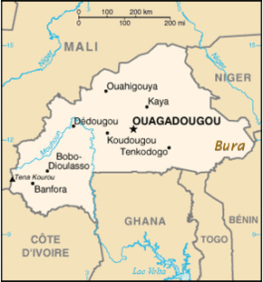

**GPS coordinates:**

**Cultural Affiliation:**

**Medium: terra cotta**

**Dimensions: H 9 in**

**Weight: 1.35 kilos**

**Condition: original**

**Provenance:** field collected in the 1950's

**Discussion:**

**References:**

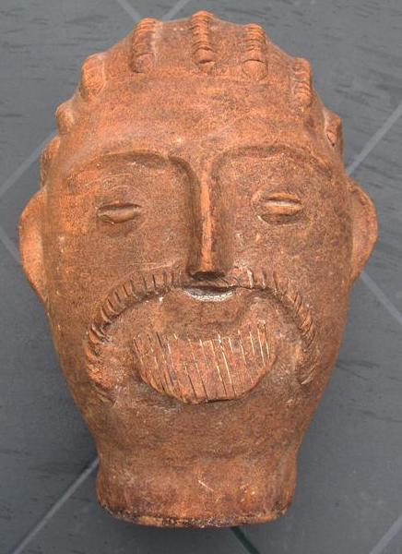

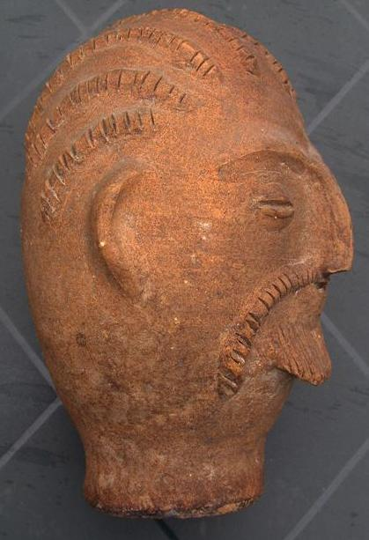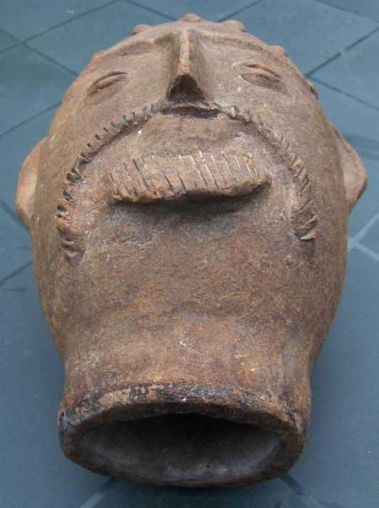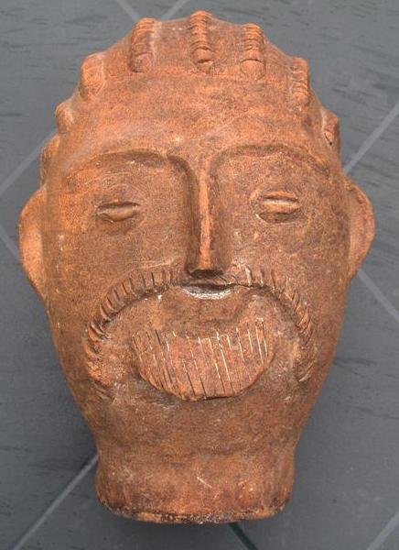 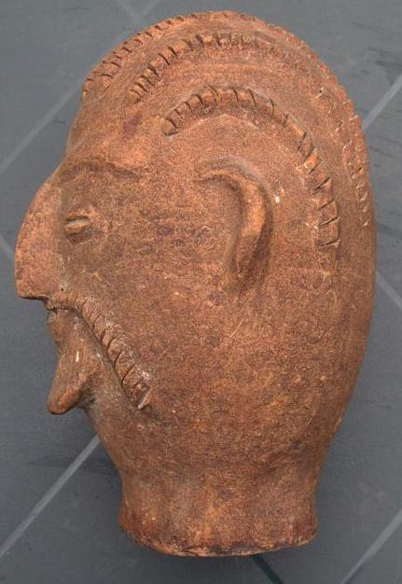 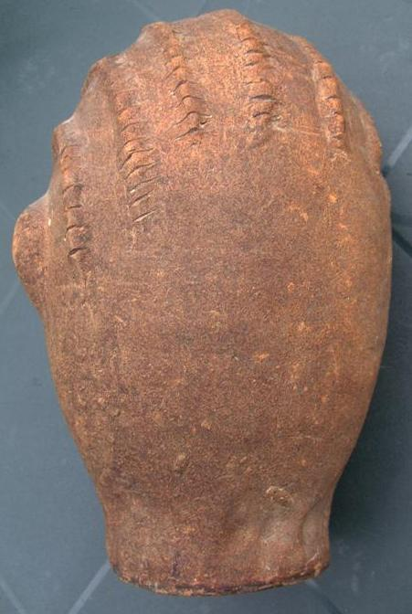

|  |
| --- |
| **Ralph J Coffman Jr**  149 Atlantic Ave  Swampscott MA 01907-2427  United States |

## Order details

|  |  |  |  |
| --- | --- | --- | --- |
| **Item title** | **Available actions** | **Shipping & handling (estimated delivery*)** | **Price** |

[Printer version](http://payments.ebay.com/ws/eBayISAPI.dll?ViewPaymentStatus&transid=1076560043012&userloginid=802-867&printerversion=true&itemid=220831204047)

|  |  |  |
| --- | --- | --- |
| Seller: | [**Member id** mapico1](http://myworld.ebay.com/mapico1) ( [**Feedback Score Of** 1842](http://feedback.ebay.com/ws/eBayISAPI.dll?ViewFeedback&userid=mapico1)) | [Contact seller](http://contact.ebay.com/ws/eBayISAPI.dll?ShowCoreAskSellerQuestion&frm=3998&iid=220831204047&redirect=0&requested=mapico1) |

|  |  |  |  |  |
| --- | --- | --- | --- | --- |
| Paid on Oct-16-12 via PayPal | | | | |
|  |  |  |  |  |

|  |  |  |  |  |  |  |  |
| --- | --- | --- | --- | --- | --- | --- | --- |
| [**Item Title:**mystery terra cotta head field collected early 50 ies afrika africa afrique**- opens in a new window or tab**](http://cgi.ebay.com/ws/eBayISAPI.dll?ViewItem&item=220831204047)  **Item Id:**220831204047 - Price: US $125.00  Quantity:1  Having a problem with this purchase? [We can help](javascript:;) | |  | | --- | |  | | |  |  | | --- | --- | | [View purchased item**- opens in a new window or tab**](http://cgi.ebay.com/ws/eBayISAPI.dll?ViewItemVersion&item=220831204047&view=all&tid=1076560043012) |  | | | Standard Shipping: **US $36.00**  Estimated delivery: October 18 - October 24 | US $125.00 |



**Payment Instructions:**

Thanks.

Kind regards,

Danny

|  |  |
| --- | --- |
|  |  |

[Printer version](http://payments.ebay.com/ws/eBayISAPI.dll?ViewPaymentStatus&transid=977783255011&userloginid=802-867&printerversion=true&itemid=320997240788)

|  |  |  |
| --- | --- | --- |
| Seller: | [**Member id** oldpaleos](http://myworld.ebay.com/oldpaleos) ( [**Feedback Score Of** 232](http://feedback.ebay.com/ws/eBayISAPI.dll?ViewFeedback&userid=oldpaleos)) | [Contact seller](http://contact.ebay.com/ws/eBayISAPI.dll?ShowCoreAskSellerQuestion&frm=3998&iid=320997240788&redirect=0&requested=oldpaleos) |

|  |  |  |  |  |
| --- | --- | --- | --- | --- |
| Paid on Oct-16-12 via PayPal | | | | |
|  |  |  |  |  |

|  |  |  |  |  |  |  |  |
| --- | --- | --- | --- | --- | --- | --- | --- |
| [**Item Title:**ANTIQUE DJENNE-JENO TERRACOTTA HEAD MALI**- opens in a new window or tab**](http://cgi.ebay.com/ws/eBayISAPI.dll?ViewItem&item=320997240788)  **Item Id:**320997240788 - Price: US $95.00  Quantity:1  Having a problem with this purchase? [We can help](javascript:;) | |  | | --- | |  | | |  |  | | --- | --- | | [Leave feedback](http://feedback.ebay.com/ws/eBayISAPI.dll?LeaveFeedbackShow&useridfrom=802-867&useridto=oldpaleos&item=320997240788&transactid=977783255011) |  | | | Economy Shipping: **US $10.00**  Estimated delivery: October 19 - November 1 | US $95.00 |



|  |  |  |  |  |
| --- | --- | --- | --- | --- |
|  | | |  | |
|  |  | |  |  |  |  |  |  |  |  |  |  |  |  |  |  |  |  |  |  |  |  |  |  |  | | --- | --- | --- | --- | --- | --- | --- | --- | --- | --- | --- | --- | --- | --- | --- | --- | --- | --- | --- | --- | --- | --- | --- | | |  | | --- | | |  |  |  |  |  |  |  |  |  |  |  |  |  |  |  |  |  |  | | --- | --- | --- | --- | --- | --- | --- | --- | --- | --- | --- | --- | --- | --- | --- | --- | --- | --- | | Subtotal:   |  |  | | --- | --- | | US $220.00 |  | |  | | | Shipping & handling: | US $46.00 | |  | | |  | | |  | | | Total: | US $266.00 | |  | | | | |  |  | | | | |  |